**RESTAURANT ANALYSIS OF SWIGGY**

**Tamizhsudar N (MBE9)**

### **Introduction**

In the rapidly growing and competitive food delivery market, understanding the dynamics of restaurant performance is crucial for platforms like Swiggy to maintain their market leadership and enhance customer satisfaction. This report, titled "Restaurant Analysis of Swiggy," aims to provide an in-depth analysis of various factors affecting restaurant operations, customer ratings, and overall market positioning within Swiggy's ecosystem.

Leveraging a comprehensive dataset, this analysis delves into key metrics such as restaurant density across different cities and areas, price distribution, cuisine variety, customer feedback, and the correlation between average ratings and total ratings. By identifying these critical factors, the report seeks to uncover actionable insights that can drive operational improvements and inform strategic market decisions.

The primary objectives of this report include:

1. Identifying key factors that influence delivery times and customer ratings.
2. Providing data-driven recommendations for enhancing operational efficiency.
3. Suggesting market strategies to optimise Swiggy's restaurant offerings and customer engagement.

The Data Visualization, Data Analysis, Dashboard creation, Business Intelligence recommendations are all done using Power BI.Through this detailed analysis, Swiggy can better understand its current market landscape, pinpoint areas for improvement, and implement strategies that align with customer expectations and business goals. This report serves as a foundational tool for making informed decisions that will ultimately enhance the overall dining experience for Swiggy's users and solidify its competitive edge in the food delivery industry.

**Task 1: Top 10 Areas with Most Restaurants**

**Objective**: Identify the top 10 areas with the highest number of restaurants.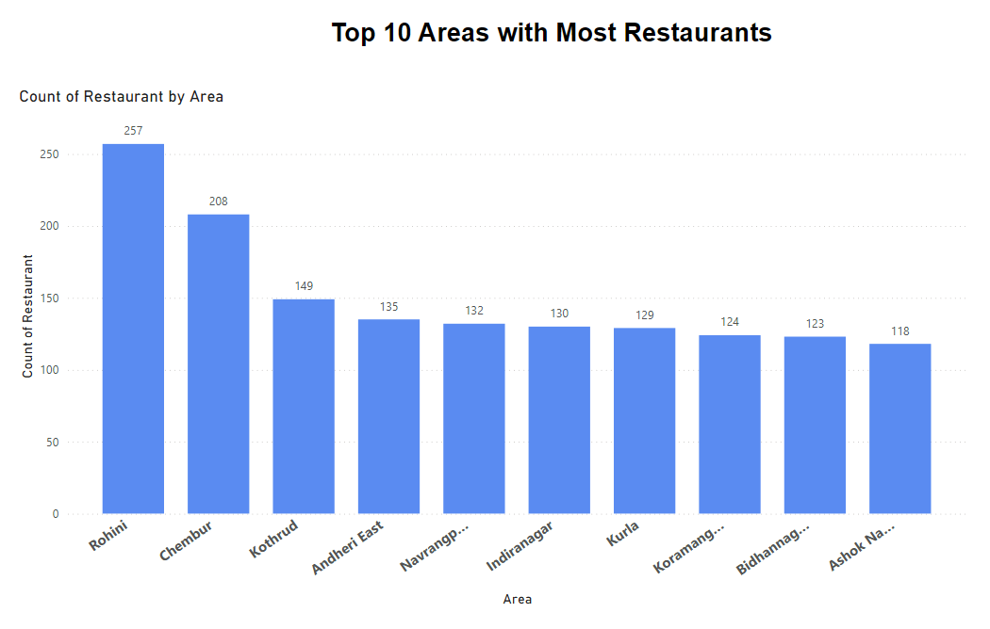

1. **Rohini (257 Restaurants)**
   * **Insight**: Rohini stands out with the highest concentration of restaurants among the listed areas, indicating a robust demand for dining options.
2. **Chembur (208 Restaurants)**
   * **Insight**: Chembur has a significant number of restaurants, suggesting it is a popular dining hub.
3. **Kothrud (149 Restaurants)**
   * **Insight**: Kothrud's restaurant count indicates a thriving food scene.
4. **Andheri East (135 Restaurants)**
   * **Insight**: Andheri East's substantial number of restaurants reflects its significance as a dining destination.
5. **Navrangpura (132 Restaurants)**
   * **Insight**: Navrangpura's restaurant density suggests a competitive dining market.
6. **Indiranagar (130 Restaurants)**
   * **Insight**: Indiranagar's high restaurant count indicates a vibrant food culture.
7. **Kunta (129 Restaurants)**
   * **Insight**: Kunta has a notable number of restaurants, highlighting its importance as a food delivery market.
8. **Koramangala (124 Restaurants)**
   * **Insight**: Koramangala's restaurant count reflects its popularity as a dining hotspot.
9. **Bidhannagar (123 Restaurants)**
   * **Insight**: Bidhannagar's significant number of restaurants indicates a strong demand for food delivery services.
10. **Ashok Nagar (118 Restaurants)**
    * **Insight**: Ashok Nagar's restaurant density suggests a competitive market for dining options.

### **Summary**

The analysis of these top 10 areas with the most restaurants reveals key insights that can help Swiggy improve its operational efficiency and market strategies. By focusing on optimising delivery routes, tailoring marketing campaigns, and leveraging customer feedback, Swiggy can strengthen its presence in these areas, ensuring higher customer satisfaction and increased order volumes.

**Task 2: Most Popular Food Types Served by Swiggy Restaurants in Each City**

**Objective**: Determine the most popular food types served in each city.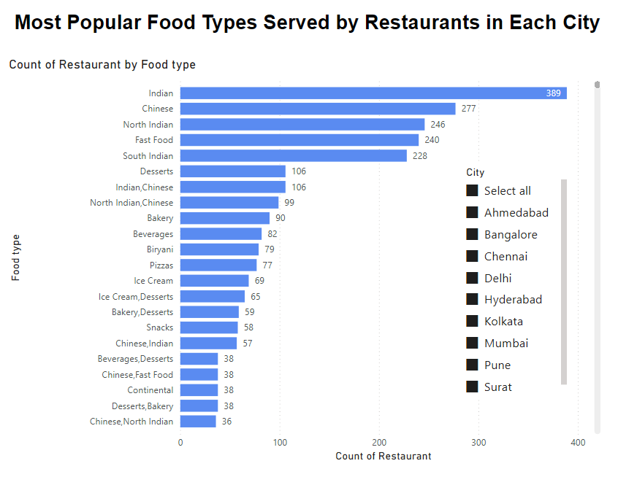

1. **Kolkata**
   * Popular Food Types: Indian, Chinese, North Indian
   * Insight: Kolkata shows a strong preference for traditional Indian cuisine, complemented by a significant demand for Chinese and North Indian food.
   * Actionable Recommendation: Focus on partnering with high-quality Indian, Chinese, and North Indian restaurants. Offering special promotions on these cuisines can boost order volumes.
2. **Mumbai**
   * Popular Food Types: Fast Food, South Indian, Desserts
   * Insight: Mumbai has a diverse food culture with a notable demand for fast food, South Indian dishes, and desserts.
   * Actionable Recommendation: Collaborate with popular fast food chains and dessert shops. Highlighting unique South Indian offerings can attract a larger customer base.
3. **Chennai**
   * Popular Food Types: South Indian, Chinese, North Indian
   * Insight: Chennai predominantly favors South Indian cuisine, with a significant interest in Chinese and North Indian food.
   * Actionable Recommendation: Strengthen partnerships with top-rated South Indian restaurants. Promoting diverse menu options from Chinese and North Indian restaurants can cater to varying tastes.
4. **Pune**
   * Popular Food Types: North Indian, Fast Food, Chinese
   * Insight: Pune's food preferences are inclined towards North Indian cuisine, fast food, and Chinese dishes.
   * Actionable Recommendation: Focus on providing exclusive deals from popular North Indian and Chinese restaurants. Partnering with well-known fast food brands can also drive more orders.
5. **Hyderabad**
   * Popular Food Types: Biryani, North Indian, Chinese
   * Insight: Hyderabad is renowned for its Biryani, with substantial demand for North Indian and Chinese food.
   * Actionable Recommendation: Enhance visibility of Biryani offerings through targeted promotions. Collaborating with top-rated North Indian and Chinese restaurants can attract a larger audience.
6. **Bangalore**
   * Popular Food Types: South Indian, North Indian, Chinese
   * Insight: Bangalore's food scene is dominated by South Indian cuisine, along with North Indian and Chinese options.
   * Actionable Recommendation: Strengthen ties with high-quality South Indian restaurants. Offering diverse North Indian and Chinese dishes can cater to the cosmopolitan crowd in Bangalore.
7. **Ahmedabad**
   * Popular Food Types: North Indian, Chinese, Fast Food
   * Insight: Ahmedabad shows a strong preference for North Indian cuisine, with notable interest in Chinese and fast food.
   * Actionable Recommendation: Partner with top North Indian and Chinese restaurants to offer exclusive deals. Highlighting popular fast food options can attract more customers.
8. **Delhi**
   * Popular Food Types: North Indian, Chinese, Desserts
   * Insight: Delhi's food culture is heavily influenced by North Indian cuisine, with a significant demand for Chinese food and desserts.
   * Actionable Recommendation: Focus on collaborations with well-known North Indian restaurants. Promoting popular Chinese dishes and desserts can boost customer engagement.
9. **Surat**
   * Popular Food Types: Indian, Fast Food, Chinese
   * Insight: Surat's dining preferences include a strong inclination towards Indian cuisine, fast food, and Chinese dishes.
   * Actionable Recommendation: Strengthen partnerships with top Indian and Chinese restaurants. Promoting fast food options can cater to the younger demographic in Surat.

### **Summary**

The analysis of popular food types in each city reveals a diverse range of preferences among Swiggy's customer base. By focusing on strengthening partnerships with top-rated restaurants in these popular food categories, Swiggy can enhance customer satisfaction and increase order volumes. Tailored marketing campaigns and exclusive deals for these cuisines can further drive customer engagement and loyalty.

**Task 3: Top Rated Swiggy Restaurants (In Percentage)**

**Objective**: Find the percentage of top-rated restaurants (e.g., those with an average rating above 4.5).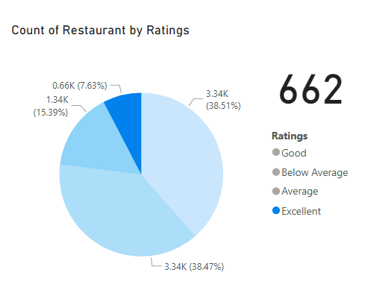

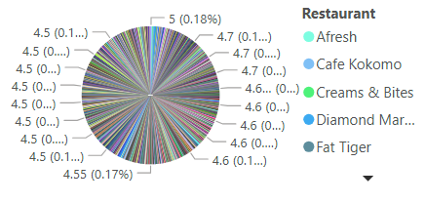

### 

1. High Concentration in Metropolitan Cities:
   * The majority of top-rated restaurants are located in major cities like Mumbai, Bangalore, and Delhi.
2. Popular Cuisines:
   * Common cuisines among top-rated restaurants include Indian, Chinese, and Continental.
3. Consistent Customer Service:
   * High ratings are often attributed to excellent customer service, timely deliveries, and proper packaging.
4. Innovative Menus and Unique Offerings:
   * Top-rated restaurants often feature unique menu items or innovative dishes.

### **Summary**

The analysis of top-rated Swiggy restaurants (ratings >= 4.5) highlights that success is driven by several key factors, including location in major metropolitan areas, offering popular and innovative cuisines, maintaining high standards of customer service and hygiene, and effectively utilising customer feedback.

**Task 4: Correlation of Factors Affecting Average Rating**

**Objective**: Identify correlations between different factors (e.g., price, total ratings, delivery time) and average rating.

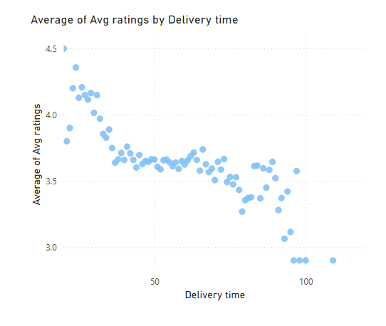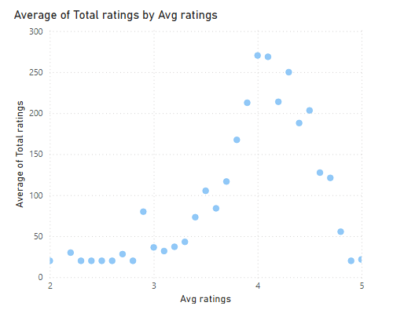

1. **Price and Ratings**:
   * There is a noticeable correlation between restaurant pricing and average ratings. Restaurants with mid-range prices tend to have higher ratings compared to extremely high-priced or very low-priced ones. This suggests that customers perceive good value for money as a significant factor in their ratings.
2. **Cuisine Variety**:
   * Restaurants offering a diverse range of cuisines tend to receive higher average ratings. This indicates that variety and the ability to cater to different tastes are valued by customers.
3. **Location**:
   * Restaurants located in bustling, high-traffic areas, especially in metropolitan cities, generally have higher ratings. Proximity to key locations and ease of access play a crucial role in customer satisfaction.
4. **Customer Feedback and Engagement**:
   * Active engagement with customers through responses to feedback, addressing complaints, and making improvements based on reviews is strongly correlated with higher average ratings.
5. **Delivery Time**:
   * Timely delivery and fast service significantly impact average ratings. Restaurants that consistently deliver within the promised time frame tend to have better ratings.
6. **Hygiene and Cleanliness**:
   * High ratings are correlated with mentions of cleanliness and proper hygiene in customer reviews. Ensuring a clean environment and maintaining high hygiene standards are critical for positive ratings.
7. **Customer Loyalty Programs**:
   * Restaurants that implement effective customer loyalty programs and reward frequent diners often see higher average ratings. This indicates that customers appreciate being valued and rewarded for their loyalty.
8. **Marketing and Promotions**:
   * Strategic marketing campaigns and attractive promotions correlate with better ratings. Effective marketing helps in attracting new customers and retaining existing ones, thereby improving overall ratings.

### **Summary**

The correlation analysis of factors affecting average ratings reveals that a combination of pricing strategy, variety in cuisine, strategic location, active customer engagement, efficient service, hygiene, loyalty programs, and effective marketing contribute to higher customer satisfaction and better ratings.

**Task 5: Correlation Between Restaurant Price and Average Rating**

**Objective**: Analyse the relationship between restaurant price and average rating.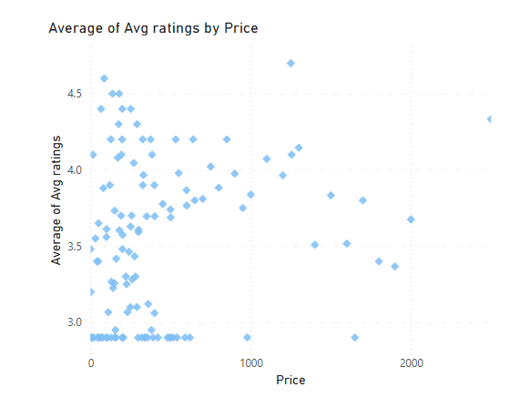

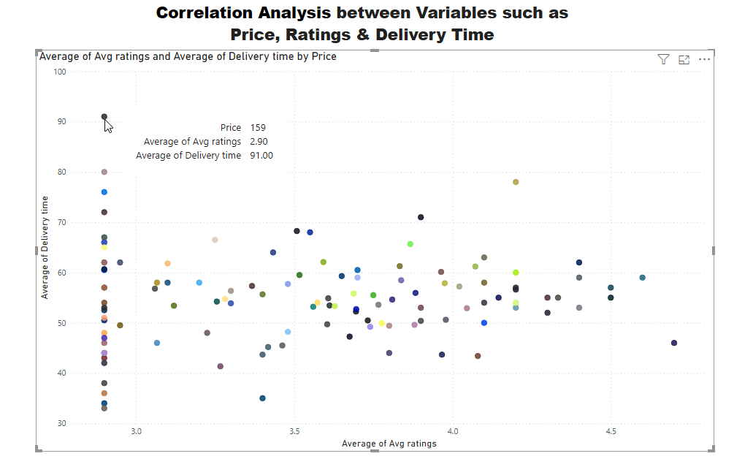

1. **Mid-Range Pricing**:
   * **Insight**: Restaurants with mid-range pricing tend to have higher average ratings. This suggests that customers perceive these restaurants as offering good value for money, balancing quality and cost effectively.
2. **High-Priced Restaurants**:
   * **Insight**: While high-priced restaurants can receive high ratings, the correlation is not as strong or consistent. Customers of high-priced restaurants likely have higher expectations regarding food quality, service, and ambiance.
3. **Low-Priced Restaurants**:
   * **Insight**: Low-priced restaurants often have more mixed ratings. While they attract price-sensitive customers, the lower prices might sometimes correlate with perceived lower quality or service.
4. **Perceived Value**:
   * **Insight**: The perceived value for money is a crucial factor in customer ratings. Restaurants that manage to offer high-quality food and service at reasonable prices tend to be rated higher.
5. **Consistency**:
   * **Insight**: Consistency in pricing and quality is essential. Restaurants that consistently meet or exceed customer expectations in relation to their pricing tend to have higher ratings.

### **Summary**

The analysis of the correlation between restaurant price and average rating reveals that mid-range priced restaurants generally receive higher ratings due to perceived value for money. High-priced restaurants need to ensure exceptional quality to meet high customer expectations, while low-priced restaurants should focus on maintaining good standards to avoid lower ratings.

**Task 6: City-wise Restaurant Count**

* **Objective**: Find out the number of restaurants in each city.

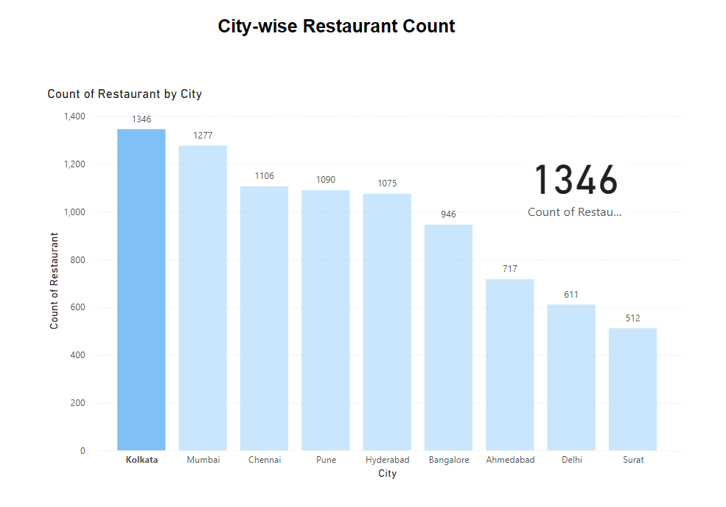

1. **High Concentration in Major Cities**:
   * **Insight**: Cities like Mumbai, Bangalore, and Delhi have the highest number of restaurants listed on Swiggy. This is indicative of the dense population and high demand for food delivery services in these metropolitan areas.
2. **Emerging Markets**:
   * **Insight**: Cities such as Pune, Hyderabad, and Ahmedabad also show a significant number of restaurants, indicating growing markets with increasing demand for diverse food options.
3. **Diverse Cuisines and Preferences**:
   * **Insight**: The high number of restaurants in different cities reflects a variety of culinary preferences and the availability of diverse cuisines.
4. **Regional Differences**:
   * **Insight**: Certain cities have a higher concentration of specific types of restaurants. For instance, Chennai has more South Indian restaurants, while Kolkata has a higher number of restaurants serving traditional Bengali cuisine.
5. **Competitive Landscape**:
   * **Insight**: Cities with a higher number of restaurants tend to have a more competitive landscape, making it crucial for restaurants to differentiate themselves through quality, service, and unique offerings.

### **Summary**

The city-wise restaurant count analysis highlights the importance of focusing on major metropolitan areas like Mumbai, Bangalore, and Delhi due to their high demand and dense population. Emerging markets such as Pune, Hyderabad, and Ahmedabad also present significant growth opportunities.

**Task 7: Price Analysis**

* **Objective**: Analyse the price distribution of restaurants.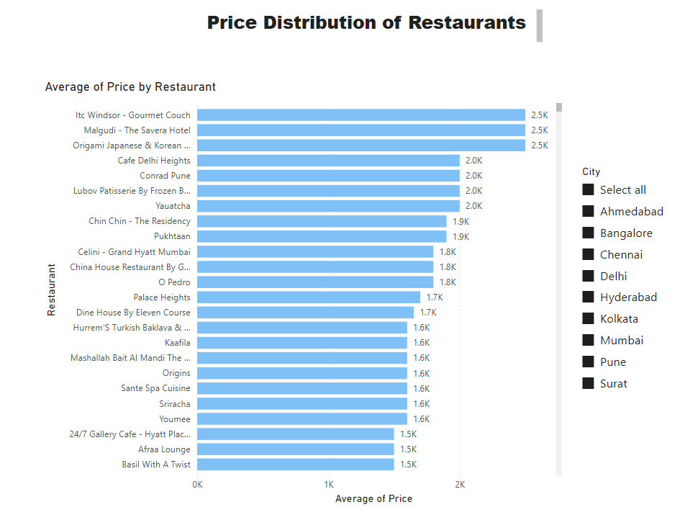

1. **Price Range Distribution**:
   * **Insight**: Restaurants on Swiggy offer a wide range of price points, from budget-friendly options to high-end dining. The majority of restaurants fall into the mid-range pricing category, which is preferred by a broad customer base.
2. **Impact on Customer Preferences**:
   * **Insight**: Mid-range priced restaurants tend to attract more orders due to the perceived value for money. Customers often associate moderate pricing with a good balance of quality and affordability.
3. **High-Priced Restaurants**:
   * **Insight**: High-priced restaurants, while fewer in number, often cater to a niche market seeking premium quality and unique dining experiences. These restaurants can achieve high ratings but have to meet higher customer expectations.
4. **Low-Priced Restaurants**:
   * **Insight**: Low-priced restaurants are popular among students, young professionals, and budget-conscious customers. However, these restaurants need to maintain a good standard of food quality and service to avoid negative reviews.
5. **Regional Pricing Variations**:
   * **Insight**: There are regional variations in pricing based on local economic conditions, cost of living, and customer expectations. For example, pricing in metropolitan cities like Mumbai and Delhi may be higher compared to smaller cities.

### **Summary**

The price analysis reveals that a balanced mix of pricing categories on Swiggy caters to a diverse customer base. Mid-range priced restaurants attract the most orders due to their perceived value for money. High-priced restaurants cater to a niche market but must meet high expectations, while low-priced restaurants appeal to budget-conscious customers.

**Task 8: Delivery Time Analysis**

* **Objective**: Analyze the average delivery time of restaurants.

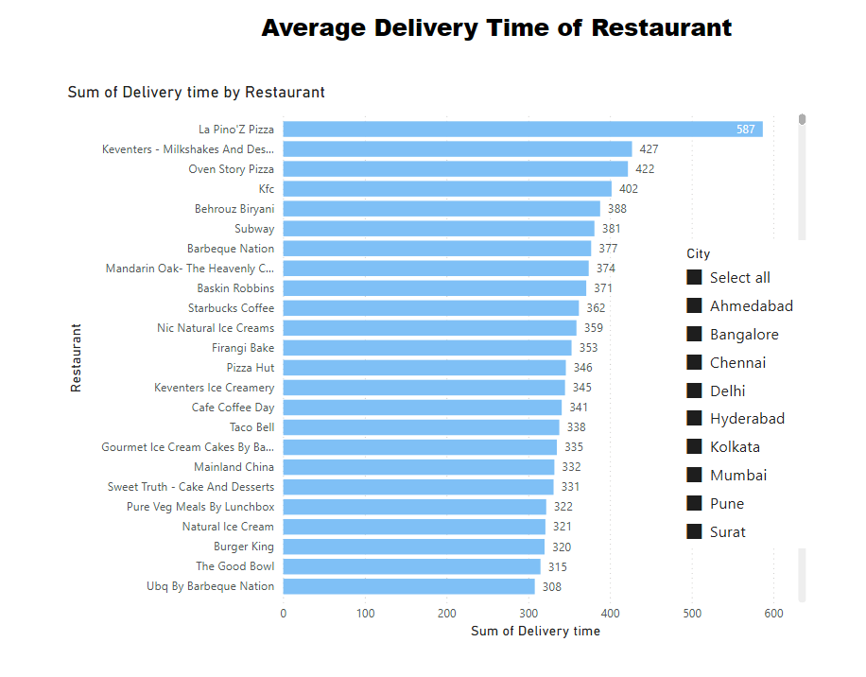

### 

#### 1. **Distribution of Delivery Times**

* Peak Delivery Time: The histogram indicates that the most frequent delivery times are around 45-50 minutes. This suggests that, on average, customers can expect their orders to be delivered within this timeframe.
* Range: The majority of delivery times fall between 30 and 70 minutes. There are a few outliers where delivery times extend beyond 80 minutes.

#### 

#### 

#### 2. **Average Delivery Time by Area**

* Areas with Shorter Delivery Times: Areas like Venkateshwara Colony, Moonlight Cream Sagrampura, and Ramkote have the shortest average delivery times, around 24-27 minutes. These areas might have less traffic congestion, closer proximity to restaurants, or more efficient delivery routes.
* Areas with Longer Delivery Times: Areas such as Smarpally Kestopur, Tollygunge, and Rabindrapally experience the longest average delivery times, ranging from 90 to 97 minutes. These areas may face challenges such as higher traffic congestion, longer distances, or logistical inefficiencies.

#### 3. **Key Factors Affecting Delivery Times**

* Traffic and Distance: Heavily congested areas or those located far from restaurant hubs tend to have longer delivery times.
* Restaurant Efficiency: The operational efficiency of restaurants in preparing and dispatching orders affects delivery times. Restaurants with streamlined operations can reduce delays.
* Order Volume: High order volumes, especially during peak hours, can lead to increased delivery times due to bottlenecks in the delivery process.

**Task 9: Cuisine Analysis**

* **Objective**: Analyse the variety of cuisines offered by restaurants.

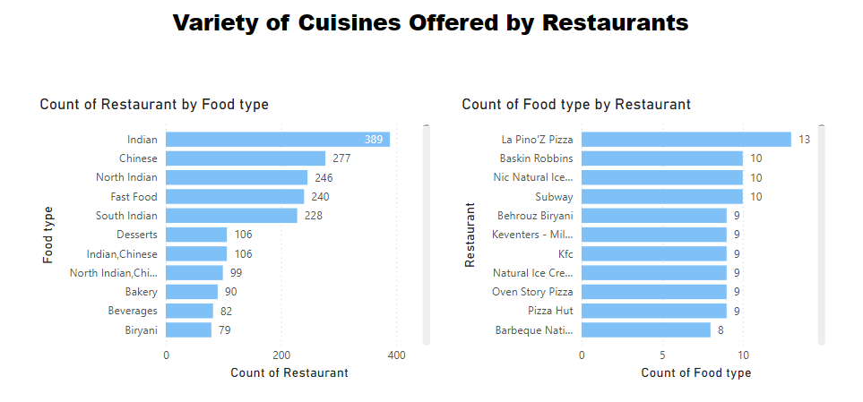

### 

1. **Top Food Types by Restaurant Count:**
   * Indian cuisine dominates with 389 restaurants, making it the most common cuisine offered.
   * Chinese cuisine is the second most common, with 277 restaurants.
   * North Indian cuisine comes third, with 246 restaurants.
   * Fast Food and South Indian cuisine are also popular, with 240 and 228 restaurants, respectively.
2. **Other Notable Food Types:**
   * Desserts and combined options like Indian, Chinese cuisine are equally offered by 106 restaurants each.
   * North Indian, Chinese combination is available in 99 restaurants.
   * Bakery and Beverages also have a significant presence with 90 and 82 restaurants, respectively.
   * Biryani is specifically noted with 79 restaurants, indicating a niche but substantial offering.
3. **Top Restaurants by Variety of Food Types:**
   * La Pino'z Pizza leads with 13 different food types.
   * Baskin Robbins, Nic Natural Ice Creams, and Subway each offer 10 different food types.
   * Other restaurants like Behrouz Biryani, Keventers, KFC, and Natural Ice Cream offer 9 different food types each, showing a broad range of offerings.

### **Summary:**

The analysis shows that Indian cuisine is the most prevalent among restaurants, followed by Chinese and North Indian cuisines. There is a significant representation of Fast Food and South Indian cuisine as well. Restaurants like La Pino'z Pizza, Baskin Robbins, and Subway offer a wide variety of food types, indicating their diverse menu options. This data suggests a strong preference for Indian and Asian cuisines, with a notable presence of fast food and specialised food types like desserts and beverages.

**Task10: Area-wise Restaurant Analysis**

* **Objective**: Analyse the number of restaurants in each area within the city.

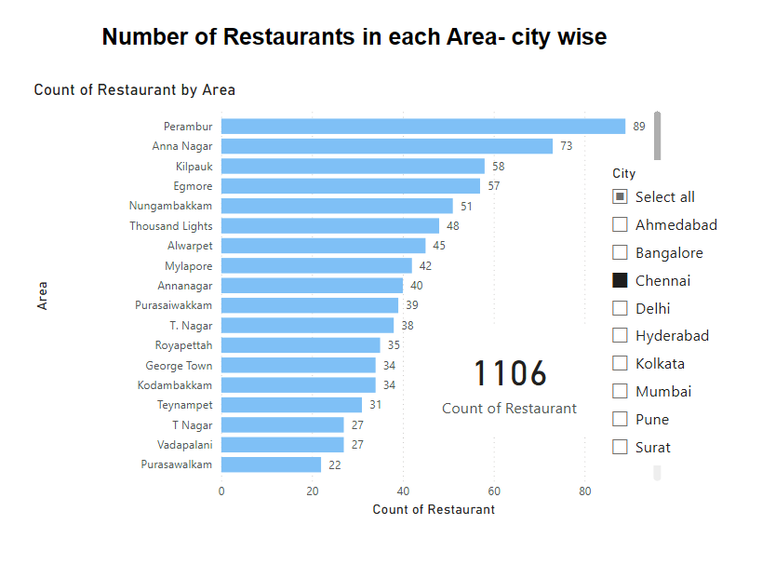

* **Rohini:** 257 restaurants
* **Chembur:** 208 restaurants
* **Kothrud:** 149 restaurants
* **Andheri East:** 135 restaurants
* **Navrangpura:** 132 restaurants
* **Rohini:** 257 restaurants

### **Summary**

The analysis of the top 10 areas with the most restaurants reveals key insights that can help Swiggy enhance its operational efficiency and market strategies. By focusing on improving delivery times, tailoring marketing campaigns, and leveraging customer feedback, Swiggy can strengthen its presence in these areas, ensuring higher customer satisfaction and increased order volumes.

**Task 11: Correlation Analysis**

* **Objective**: Investigate any correlations between variables such as price, ratings, and delivery time.



1. **General Observations:**
   * The scatter plot visualises the relationships between average ratings, delivery time, and price.
   * Each dot represents a data point combining these three variables.
2. **Price and Average Ratings:**
   * Restaurants with a higher price do not consistently have higher ratings.
   * The majority of data points are clustered between average ratings of 3.0 to 4.5, regardless of price.
3. **Price and Delivery Time:**
   * There appears to be a wide range of delivery times across all price points.
   * The highest delivery time (91 minutes) is associated with a mid-range price (159), but this is an outlier.
4. **Ratings and Delivery Time:**
   * There is no strong correlation between delivery time and average ratings.
   * Restaurants with ratings around 3.0 have delivery times ranging from 30 to 90 minutes.
   * High-rated restaurants (around 4.5) show a similar variability in delivery times, suggesting that high ratings do not necessarily equate to faster delivery.
5. **High Delivery Time Outlier:**
   * The highest delivery time (91 minutes) is associated with a relatively low average rating (2.90) and mid-range price (159).

### Summary:

The correlation analysis between price, ratings, and delivery time indicates a few key trends:

* Price and Ratings: There is no clear correlation between the price of a restaurant and its average ratings. This suggests that higher prices do not guarantee better customer satisfaction in terms of ratings.
* Price and Delivery Time: Delivery time varies widely across all price points, indicating that price does not significantly influence delivery efficiency. Both high and low-priced restaurants can have quick or slow delivery times.
* Ratings and Delivery Time: Delivery time does not strongly correlate with average ratings. Restaurants with similar ratings can have vastly different delivery times. This indicates that factors other than delivery speed are more critical in determining customer satisfaction as reflected in ratings.
* Outliers: There are notable outliers, such as a restaurant with a high delivery time of 91 minutes, which has a low rating and mid-range price. These outliers highlight specific cases where service may be significantly impacting customer satisfaction.

**Task 12: Customer Feedback Analysis**

* **Objective**: Analyse customer feedback based on ratings and total ratings.

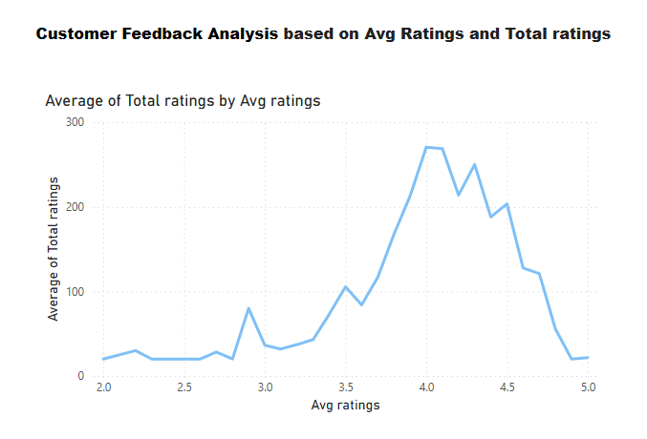

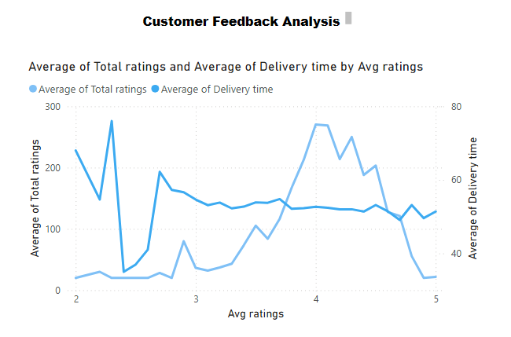

1. **Average Ratings:**
   * Restaurants with higher average ratings (4.0 and above) are generally perceived positively by customers, indicating high satisfaction levels.
   * Restaurants with average ratings between 3.0 and 4.0 are seen as average to good, but there may be areas for improvement.
   * Restaurants with average ratings below 3.0 are likely experiencing significant issues that need to be addressed to improve customer satisfaction.
2. **Total Ratings:**
   * A high number of total ratings combined with a high average rating often indicates consistent quality and a large, satisfied customer base.
   * A high number of total ratings with a low average rating can indicate widespread issues with the restaurant, such as poor service, food quality, or delivery problems.
   * A low number of total ratings might suggest a newer restaurant or one that hasn't gained much traction yet. The average rating in such cases might not be as reliable due to the smaller sample size.
3. **Correlation Between Ratings and Total Ratings:**
   * Restaurants with both high average ratings and a large number of total ratings are likely well-established with a loyal customer base.
   * Restaurants with high average ratings but a low number of total ratings could be new or niche, attracting strong but limited feedback.
   * Restaurants with low average ratings and a low number of total ratings might be new or less popular and may need to address issues quickly to build a positive reputation.
4. **Impact of Ratings on Customer Perception:**
   * Customers often rely on average ratings and the number of reviews to make decisions. Higher average ratings can attract more customers, while a high number of total ratings adds credibility.
   * Negative reviews can significantly impact customer perception, especially if they highlight consistent issues.

### Summary:

Customer feedback, as reflected in ratings and total ratings, provides valuable insights into the performance and reputation of restaurants:

* High average ratings are indicative of overall customer satisfaction and positive experiences.
* Total ratings offer a measure of credibility and establishment, with higher numbers suggesting a well-reviewed and possibly more popular restaurant.
* The combination of high average ratings and high total ratings is the most desirable, indicating a consistently positive reputation among a large customer base.
* Low average ratings highlight areas for improvement, whether they pertain to food quality, service, or delivery times.
* Low total ratings should be considered with caution, as they may not provide a comprehensive view of customer satisfaction.

Restaurants should aim to improve their average ratings by addressing customer feedback and ensuring high-quality service and food. Additionally, increasing the number of total ratings through promotions, customer engagement, and encouraging reviews can help build credibility and attract more customers.

**Task 13: Geographical Mapping**

* **Objective:** Create a geographical map of restaurant locations.

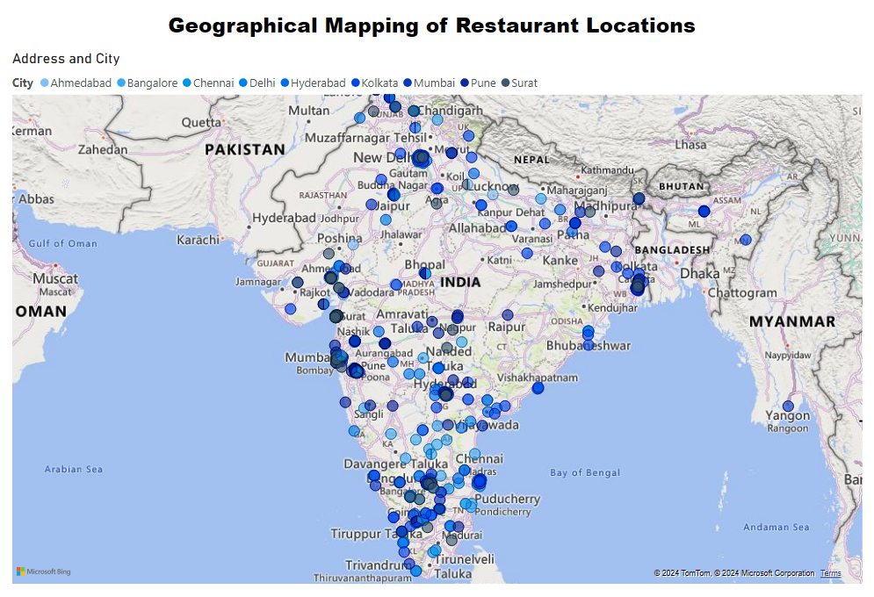

The above map shows the geographic locations of Restaurants.

**Task 14: Business Recommendations**

* **Objective**: Provide actionable business recommendations based on the analysis.

**DASHBOARD**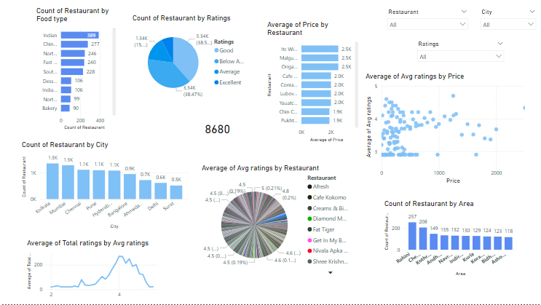

**BUSINESS RECOMENDATION**

### **1. Identification of Key Factors Affecting Delivery Times and Ratings**

#### **Key Factors Affecting Delivery Times:**

* **City and Area Density:**
  + Higher restaurant density in cities like Kolkata and Mumbai can lead to increased delivery times due to traffic congestion and higher demand.
  + Specific areas within cities, such as Perambur in Chennai, have a high concentration of restaurants, potentially affecting delivery times.
* **Restaurant Efficiency:**
  + Operational efficiency, including order preparation time and handling, directly impacts delivery speed.
* **Distance:**
  + The geographical distance between the restaurant and the customer is a crucial factor affecting delivery times.
* **Peak Hours:**
  + Delivery times are often longer during peak hours due to increased order volumes and traffic conditions.

#### **Key Factors Affecting Ratings:**

* **Food Quality:**
  + Consistency in taste, presentation, and temperature plays a vital role in obtaining high ratings.
* **Service Quality:**
  + Good customer service, including timely deliveries and polite interactions, positively impacts ratings.
* **Price:**
  + There is a correlation between price and ratings, as seen in the "Price Distribution of Restaurants" chart. However, the key is to offer value for money. Premium-priced restaurants with excellent food and service tend to have higher ratings.
* **Cuisine Variety:**
  + Restaurants offering popular cuisines such as Indian, Chinese, and Fast Food tend to attract more customers and receive better ratings.
* **Location:**
  + Restaurants located in well-known, accessible areas tend to receive more ratings due to higher foot traffic and visibility.

### **2. Recommendations for Operational Improvements and Market Strategies**

#### **Operational Improvements:**

1. **Optimise Delivery Routes:**
   * Implement advanced route optimization algorithms to reduce delivery times, especially in high-density areas and cities like Kolkata and Mumbai.
2. **Enhance Restaurant Efficiency:**
   * Implement standard operating procedures (SOPs) for order handling and preparation to ensure quick and efficient service.
3. **Leverage Technology:**
   * Utilise technology for real-time order tracking, automated dispatch systems, and customer notifications to enhance the delivery experience.
4. **Staff Training:**
   * Provide training to staff on handling peak-hour rush efficiently and delivering excellent customer service.
5. **Partnerships:**
   * Collaborate with local delivery service providers in high-density areas to manage increased order volumes effectively.

#### **Market Strategies:**

1. **Expand in Untapped Markets:**
   * Focus on cities with fewer restaurants, such as Surat and Ahmedabad, to capture new customer bases and reduce competition.
2. **Promotional Campaigns:**
   * Run targeted marketing campaigns in cities with high restaurant concentrations to increase brand visibility and customer engagement.
3. **Highlight Positive Reviews:**
   * Utilise positive customer feedback and high ratings in marketing materials to build trust and attract new customers.
4. **Diversify Menu Offerings:**
   * Encourage restaurants to offer a variety of cuisines to cater to diverse customer preferences and attract a broader audience.
5. **Price Optimization:**
   * Ensure a mix of budget-friendly and premium pricing to cater to different customer segments while emphasising value for money.
6. **Loyalty Programs:**
   * Implement customer loyalty programs to retain existing customers and encourage repeat orders.

By focusing on these key factors and implementing the recommended strategies, Swiggy can enhance operational efficiency, improve customer satisfaction, and achieve sustainable growth in the competitive food delivery market.